Visualizing and Predicting Heart Diseases with an Interactive Dashboard

**NALAIYA THIRAN PROJECT REPORT**

# 2022

***Submitted by***

|  |  |
| --- | --- |
| **Swetha V** | **812819104045** |
| **Boomika M** | **812819104004** |
| **Monisha R** | **812819104029** |
| **Sankari S** | **812819104041** |

**Team ID: PNT2022TMID45611**

**Content**

1. **INTRODUCTION**
   1. Project Overview
   2. Purpose
2. **LITERATURE SURVEY**
   1. Existing problem
   2. References
   3. Problem Statement Definition
3. **IDEATION & PROPOSED SOLUTION**
   1. Empathy Map Canvas
   2. Ideation & Brainstorming
   3. Proposed Solution
   4. Problem Solution fit
4. **REQUIREMENT ANALYSIS**
   1. Functional requirement
   2. Non-Functional requirements
5. **PROJECT DESIGN**
   1. Data Flow Diagrams
   2. Solution & Technical Architecture
   3. User Stories
6. **PROJECT PLANNING & SCHEDULING**
   1. Sprint Planning & Estimation
   2. Sprint Delivery Schedule
   3. Reports from JIRA
7. **CODING & SOLUTIONING (Explain the features added in the project along with code)**
   1. Feature 1
   2. Feature 2
8. **TESTING**
   1. Test Cases
   2. User Acceptance Testing
9. **RESULTS**
   1. Performance Metrics
10. **ADVANTAGES & DISADVANTAGES**
11. **CONCLUSION**
12. **FUTURE SCOPE**

# TEAM ID : PNT2022TMID45611

**VISUALIZING AND PREDICTING HEART DISEASES WITH AN INTERACTIVE DASHBOARD**

# Introduction

## Project Overview

The leading cause of death in the developed world is heart disease. Therefore, there needs to be work done to help prevent the risks of having a heart attack or stroke. This project aims to create an interactive Dashboard using IBM Cognos Tool and dataset to predict which patients are most likely to suffer from a heart disease in the near future using the features given.

## Purpose

Heart disease (HD) is a major cause of mortality in modern society. Medical diagnosis is an extremely important but complicated task that should be performed accurately and efficiently. Cardiovascular disease is difficult to detect due to several risk factors, including high blood pressure, cholesterol, and an abnormal pulse rate. Based on the analytics we can analyze which patients are most likely to suffer from heart disease in the near future and based on the patient details we will make decisions to cure them.

# Literature Survey

## Existing Problem

Healthcare industries generate enormous amount of data, so called big data that accommodates hidden knowledge or pattern for decision making. The huge volume of data is used to make decision which is more accurate than intuition. Exploratory Data Analysis (EDA) detects mistakes, finds appropriate data, checks assumptions and determines the correlation among the explanatory variables. In the context, EDA is considered as analysing data that excludes inferences and statistical modelling. Analytics is an essential technique for any profession as it forecast the future and hidden pattern. Data analytics is considered as a cost effective technology in the recent past and it plays an essential role in healthcare which includes new research findings, emergency situations and outbreaks of disease. The use of analytics in healthcare improves care by facilitating preventive care and EDA is a vital step while analysing data..

## References

**“Heart Disease Prediction using Exploratory Data Analysis” R. Indrakumari, T.Poongodi, Soumya Ranjan Jena**

In this paper, the risk factors that causes heart disease is considered and predicted using K-means algorithm and the analysis is carried out using a publicly available data for heart disease. The dataset holds 209 records with 8 attributes such as age, chest pain type, blood pressure, blood glucose level, ECG in rest, heart rate and four types of chest pain. To predict the heart disease, K- means clustering algorithm is used along with data analytics and visualization tool. The paper discusses the pre-processing methods, classifier performances and evaluation metrics. In the result section, the visualized data shows that the prediction is accurate.

## Prediction of heart disease at early stage using data mining and big data analytics: A survey

**N. K. Salma Banu, Suma Swamy**

Several studies have been carried out for developing prediction model using individual technique and also by combining two or more techniques. This paper provides a quick and easy review and understanding of available prediction models using data mining from 2004 to 2016. The comparison shows the accuracy level of each model given by different researchers. Into practice.

* 1. **Problem Statement Definition**

# Who does the problem affect?

People with unhealthy lifestyles, stress, depression, age above 40 and when their ancestors got heart disease (since heart disease is hereditary).

# When does the issue occur?

The issue occurs for people with unhealthy lifestyles and age above 40. Where is the issue occurring? The issue is originating from an unhealthy lifestyle. It mostly occurs in the blood valves of the heart.

# What would happen if we didn’t solve the problem?

If we don’t solve the problem, many people will die at a young age. The death rate due to heart disease will increase rapidly.

# Why is it important to fix the problem?

We should predict the problem before giving treatment to the patients. As the problem is predicted early, we can solve it easily and early.

# Ideation and Proposed Solution

## Empathy Map Canvas

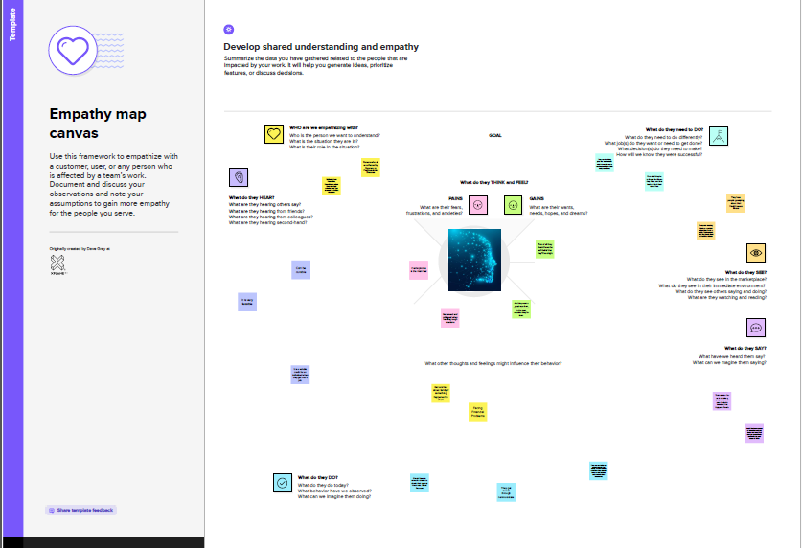

* 1. **Ideation and Brainstorming**

Step-1: Team Gathering, Collaboration and Select the Problem Statement

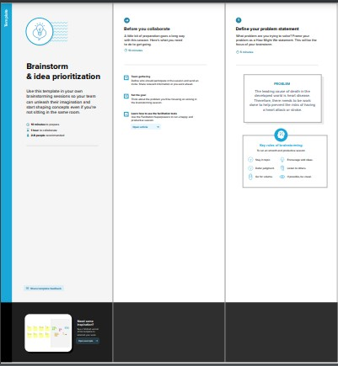

Step-2: Brainstorm, Idea Listing and Grouping

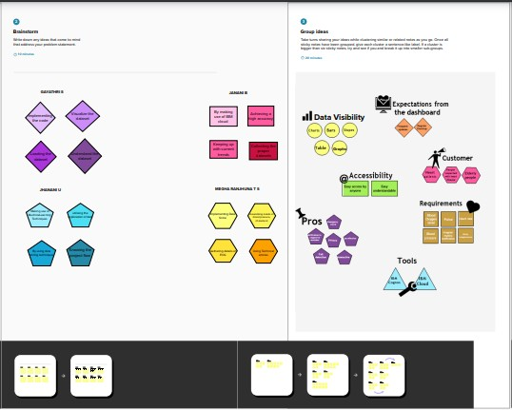

Step-3: Idea Prioritization

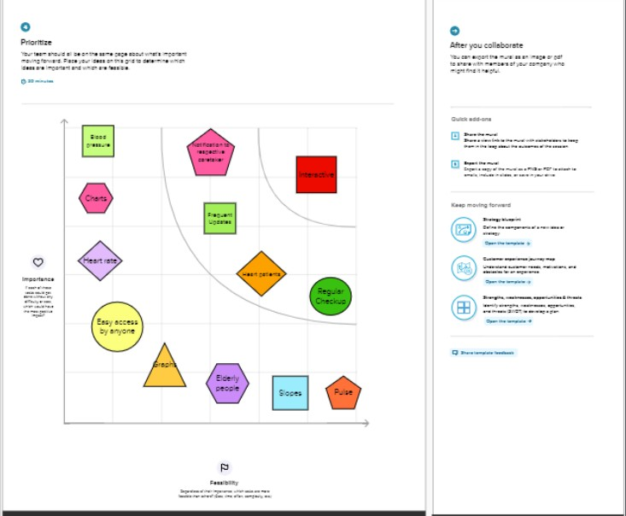

## Proposed Solution

|  |  |  |
| --- | --- | --- |
| **S.No.** | **Parameter** | **Description** |
| 1. | Problem Statement (Problem to be solved) | The leading cause of death in the developed world is heart disease. As a result, work must be done to reduce the risks of having a heart attack or stroke. It is infeasible for a common man to frequently undergo tests for ECG and so on. Hence , it requires a  replacement that is both convenient and dependable. |
| 2. | Idea / Solution description | The proposed solution proposes an interactive dashboard for visualizing and forecasting heart disorders, in which the user may observe his/her |

|  |  |  |
| --- | --- | --- |
|  |  | medical report analysis as well as the projected end result. IBM Cognos will be used to create the dashboard. Machine learning Algorithms will be used to forecast cardiac disease. |
| 3. | Novelty / Uniqueness | Makes recommendations to the user based on that person's medical analysis. |
| 4. | Social Impact / Customer Satisfaction | It helps with disease prediction at an early stage and frequently alerts the user to their current health status.Both the user and the doctor can benefit from the system's improved decision-making regarding cardiac disease |
| 5. | Business Model (Revenue Model) | Can be deployed by Hospitals or NFOs, so that it makes the analysis in a fast manner. |
| 6. | Scalability of the Solution | The solution can work effectively on long and small datasets. It can also be changed to predict various other diseases depending on the dataset |

* 1. **Problem Solution Fit**

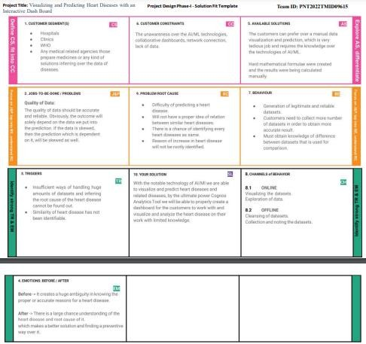

# Requirement Analysis

## Functional Requirement

Following are the functional requirements of the proposed solution.

|  |  |  |
| --- | --- | --- |
| **FR No.** | **Functional Requirement (Epic)** | **Sub Requirement (Story / Sub-Task)** |
| FR-1 | User Registration | Enables user to make registration for the application  through Gmail |
| FR-2 | User Confirmation | Once after registration, the user will get confirmation via Email |
| FR-3 | Visualizing Data | User can visualize the trends on the heart disease through Dashboard created using IBM Cognos Analytics |
| FR-4 | Generation Report | User can view his/her health report and can make decisions accordingly |

## Non-Functional Requirement

Following are the non-functional requirements of the proposed solution.

|  |  |  |
| --- | --- | --- |
| **FR No.** | **Non-Functional Requirement** | **Description** |
| NFR-1 | **Usability** | The application will have a simple and userfriendly graphical interface. Users will be ableto understand and use all the features of the application easily. Any  action has to be performed with just a few clicks |
| NFR-2 | **Security** | For security of the application the technique known as database replication should be used so that all the important data should be kept safe. Incase of crash, the system should be able to backup and recover the data |
| NFR-3 | **Reliability** | The application has to be consistent at every scenario and has to work without failure in any  environment |
| NFR-4 | **Performance** | Performance of the application depends on the response time and the speed of the data submission. The response time of the application is direct and faster which depends on the efficiency  of implemented algorithm |
| NFR-5 | **Availability** | The application has to be available 24 x 7 for users without any interruption |
| NFR-6 | **Scalability** | The application can withstand the increase in the no. of users and has to be able to develop Higher versions |

# Project Design

## Data Flow Diagram

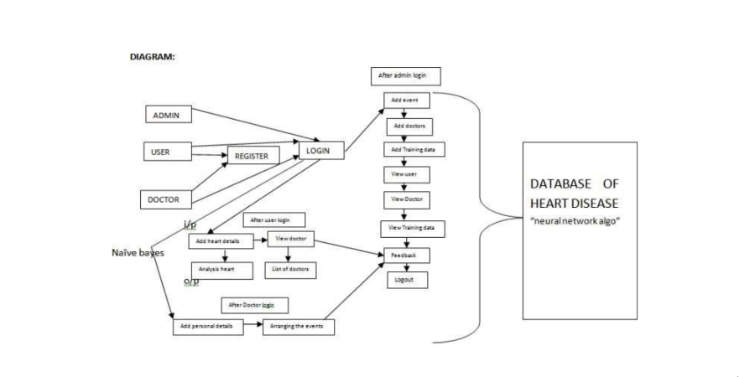

* 1. **Solution and Technical Architecture 5.3**

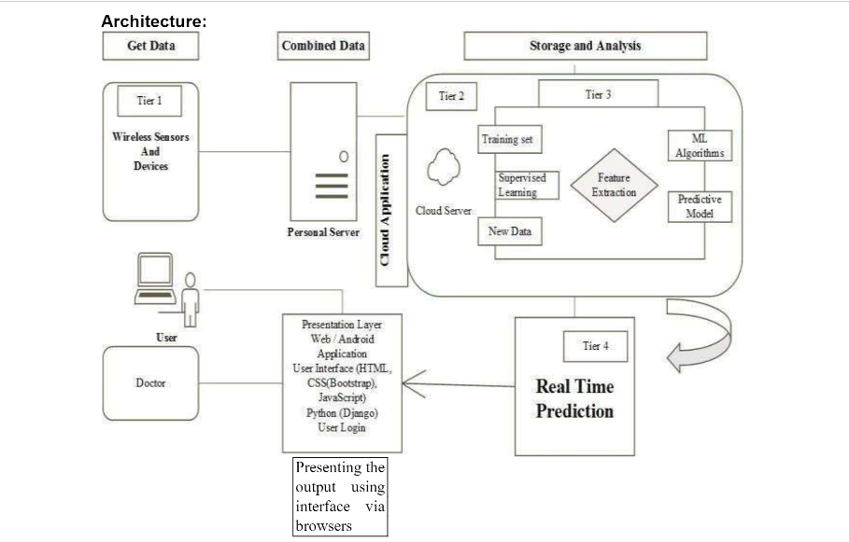

|  |  |  |  |  |  |  |  |  |
| --- | --- | --- | --- | --- | --- | --- | --- | --- |
| 1. **Project Planning and Scheduling**    1. **Script Planning and Execution** | | | | | | | |  |
|  | **Sprint** | **Functional**  **Requirement (Epic)** | **User Story Number** | **User Story / Task** | **Story Points** | **Priority** | **Team Members** |  |
| Sprint-1 | Registration | USN-1 | As a user, I can register for the application by entering my email, password, and confirming  my password | 3 | High | 1 |  |
| Sprint-1 |  | USN-2 | As a user, I will receive confirmation email once I have registered for the  application | 3 | High | 3 |  |
| Sprint-1 |  | USN-3 | As a user, I can register for the application through Gmail | 3 | Medium | 1 |  |
| Sprint-1 | Login | USN-4 | As a user, I can log into the application by entering email & password | 6 | High | 5 |  |
| Sprint-2 | Dashboard | USN-5 | Attractive dashboard For the Application | 3 | Medium | 3 |  |
| Sprint-2 |  | USN-6 | Profile - view & update your profile | 5 | Low | 2 |  |
| Sprint-2 |  | USN-7 | Home - Analyze your Heart problem | 2 | High | 4 |  |
| Sprint-2 |  | USN-8 | The user will have to fill in the below 13 fields for the system to predict a disease  -Age in year -Gender  -Chest pain Type  -Fasting Blood Sugar  -Resting Electrographic Results  -Exercise Induced Angina  -Trust Blood Pressure | 7 | High | 2 |  |
| Sprint-3 | Support | USN-9 | Get feedback from users | 10 | Medium | 3 |  |
| Sprint-3 |  | USN-10 | Responds to user queries via telephone,email etc. | 3 | Medium | 2 |  |
| Sprint-3 |  | USN-11 | The team must respond immediately to the queries based on the priority | 5 | High | 5 |  |
| Sprint-4 | System Requirements | USN-12 | Hardware Requirement  3. Laptop or PC   * i5 processor system or higher * 4 GB RAM or higher * 128 GB ROM or higher   4. Mobile   * (12.0 and above) | 5 | Low | 2 |  |
| Sprint-4 |  | USN-13 | Software Requirement  2. Laptop or PC | 8 | Medium | 4 |  |
|  | | | | | | | |  |

|  |  |  |  |  |  |  |  |  |  |  |  |  |
| --- | --- | --- | --- | --- | --- | --- | --- | --- | --- | --- | --- | --- |
|  | | | | | | | | | | | |  |
|  |  |  | | |  | * Windows 10 or higher * Android Studio | |  |  | |  |  |
| **6.2 Sprint Delivery Schedule** | | | | | | | | | | | |  |
|  | **Sprint** | | **Total Story Points** | **Duration** | | **Sprint Start Date** | **Sprint End Date (Planned)** | **Story Points Completed (as on**  **Planned End Date)** | | **Sprint Releas Date (Actual)** | | **e** |
|  | Sprint-1 | | 20 | 6 Days | | 24 Oct 2022 | 29 Oct 2022 | 20 | | 29 Oct 2022 | |  |
|  | Sprint-2 | | 20 | 6 Days | | 30 Oct 2022 | 04 Nov 2022 | 17 | | 04 Nov 2022 | |  |
|  | Sprint-3 | | 20 | 6 Days | | 05 Nov 2022 | 11 Nov 2022 | 18 | | 11 Nov 2022 | |  |
|  | Sprint-4 | | 20 | 6 Days | | 12 Nov 2022 | 17 Nov 2022 | 19 | | 17 Nov 2022 | |  |
|  | | | | | | | | | | | |  |

# Coding And Solutioning

## Machine Learning

Learning which model is best for the given Dataset

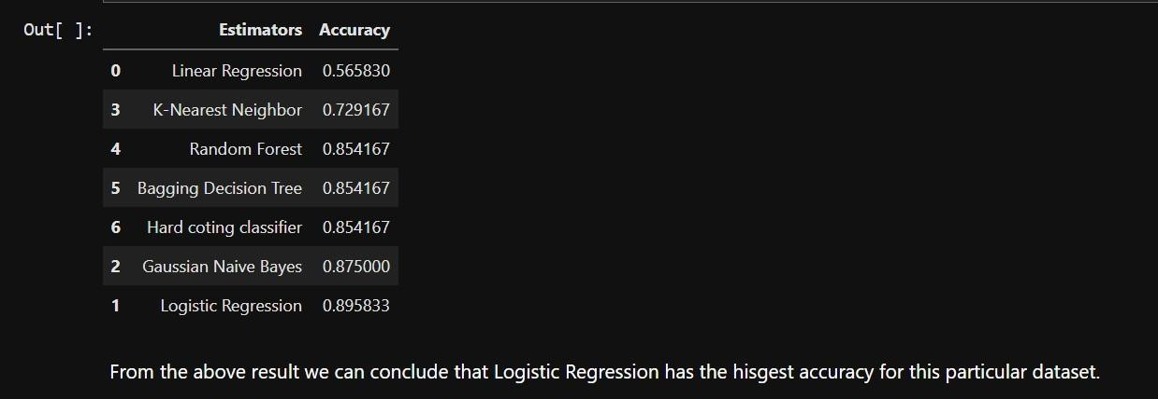

Comparing it with the accuracy gotten from Decision Tree:

*TP=cm[0][0] #cm=Confusion Matrix TN=cm[1][1]*

*FN=cm[1][0]*

*FP=cm[0][1]*

*print('Testing Accuracy for Decision Tree:',(TP+TN)/(TP+TN+FN+FP)) print('Testing Sensitivity for Decision Tree:',(TP/(TP+FN))) print('Testing Specificity for Decision Tree:',(TN/(TN+FP))) print('Testing Precision for Decision Tree:',(TP/(TP+FP)))*



## Dashboard

Average BP during chest pain

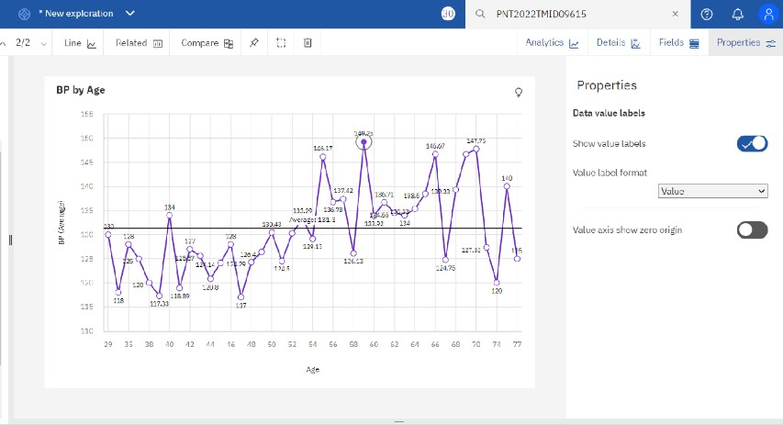

Exploration Of BPvsChestPainType And Gender:

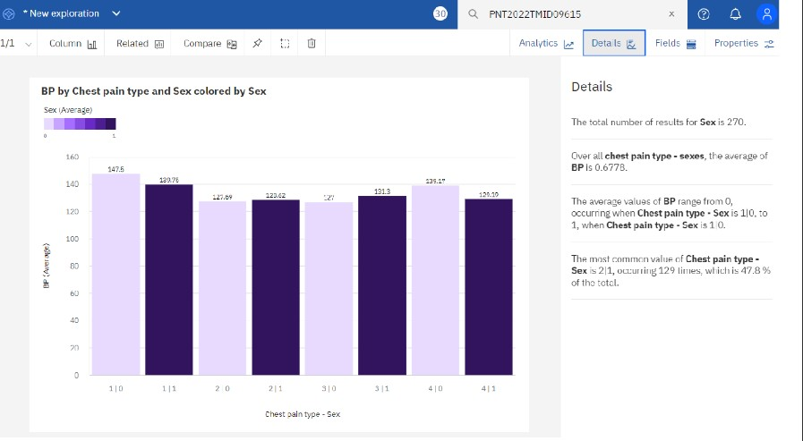

Exploration Of Max Heart Rate During The Chest Pain:

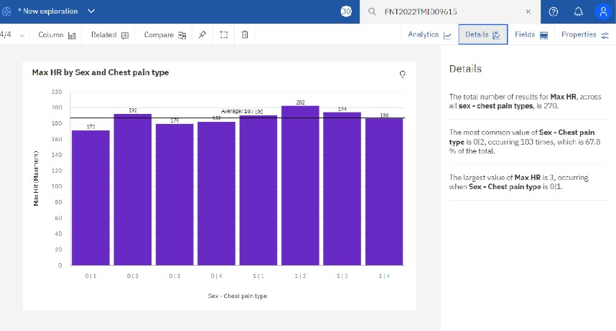

Exploration Of Cholesterol by age and Gender:

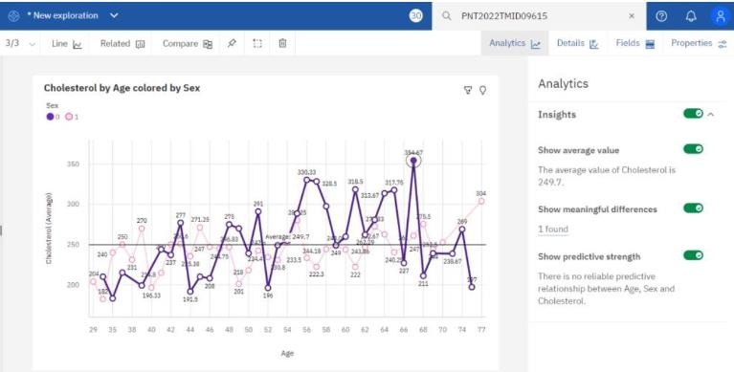

**Dashboard Showing Different Types Of Visuals:**

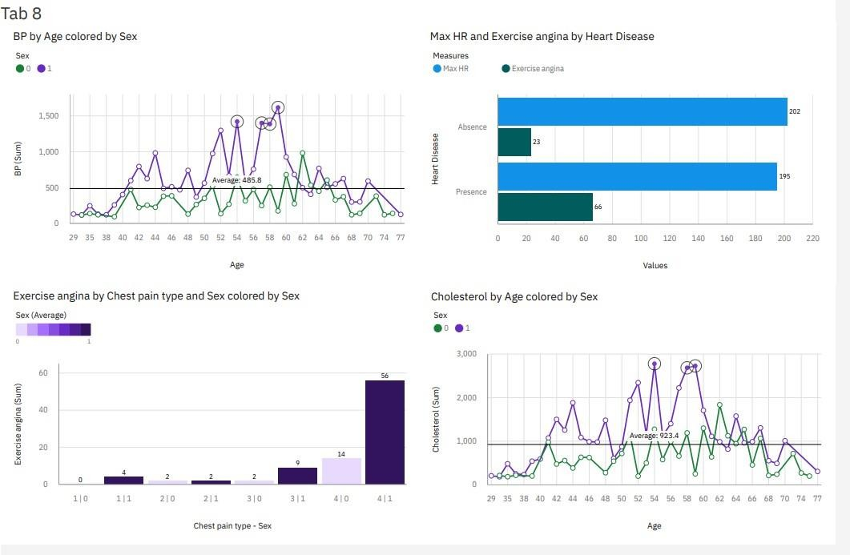

# Testing

## Test Cases

Testing the data model for various input values.

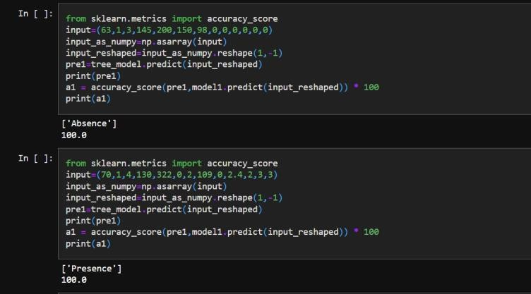

## User acceptance Testing

Testing a case where user has heart disease

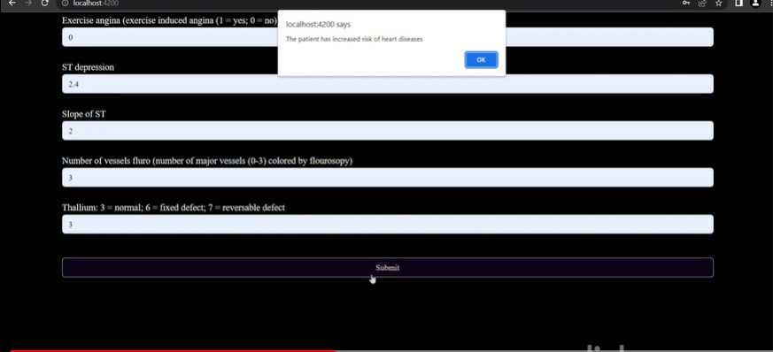

Testing a case where user does not have heart disease

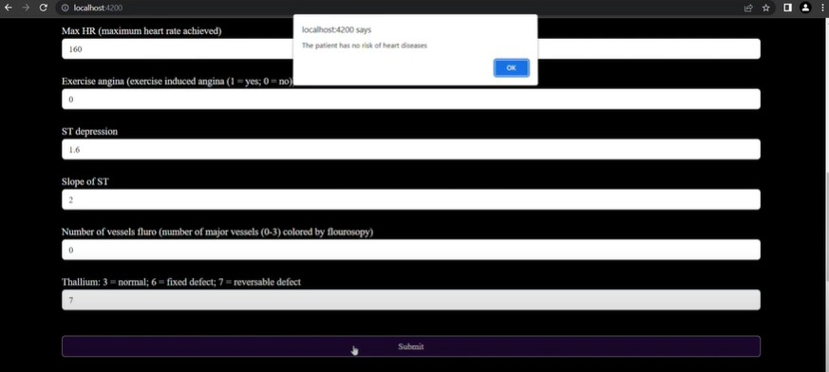

# Result

## Performance Metrics

The confusion matrix below shows the performance metrics of the machine learning model.

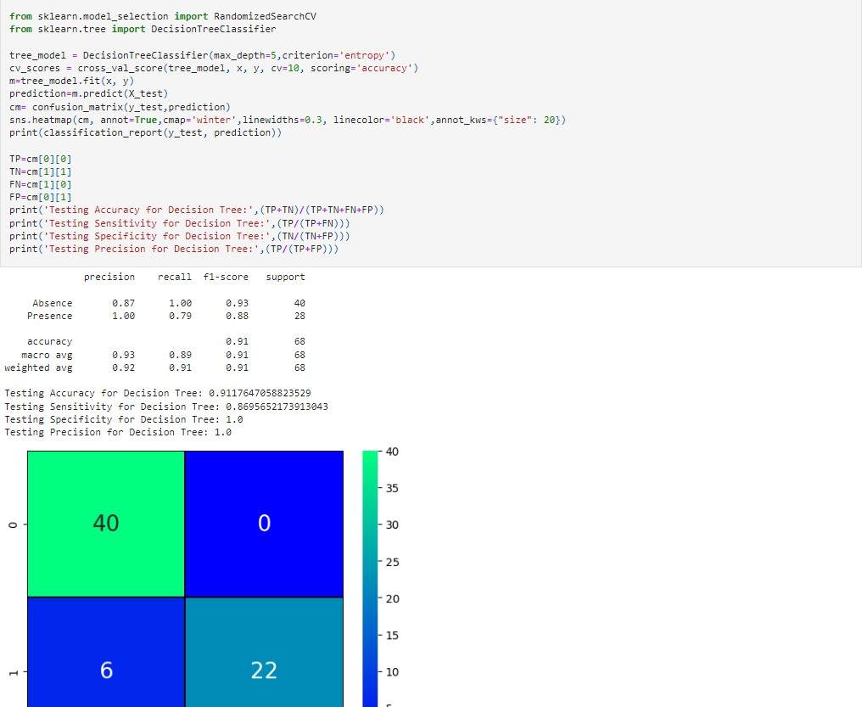

# Advantages Disadvantages

## Advantages:

* This is one of the fastest ways to determine if a person is likely to suffer from a heart disease or not.
* Useful for medical practitioners to easily classify their patients.
* User Friendly
* Easy to understand
* Secure
* Dashboard provides insightful informations

## Disadvantages:

* Needs work
* Users need to know all the fields
* Does Not take null value as input
* Does not provide suggestions to user

# Conclusion

Complications of heart disease include heart attack and stroke. You can reduce the risk of complications with early diagnosis and treatment. So the suggestion that we get from the website might help save patients. It is always to get treated in the early stages of heart disease.

1. **Future Scope**

Like the saying goes “Prevention is better than cure”. We have to look into methods to prevent heart diseases altogether other than just predicting it in early stages.

To use this website we need to take a lot of tests beforehand. So it would be better if we require less attributes and still give an effective result